Tittle: The gang

Description

The gang is an application that will help the its users to the remember about the events planned prior to its occurrence.

Problem

Events are held on specified dates and so many of them from our friends and close peoples in our lives, some events are so crucial such that we really need not to miss. Some of the events include weddings, funerals, charity events, birthday events, appointments, conferences, trade shows, workshops, team building events. For instance, all the events sometimes are planned on different days and we often forget some that were so crucial.

The gang is an application that helps to keep track of the events and the dates they are happening and the requirements towards the event.

Its advantagesTop of Form

Bottom of Form

* Improved Time Management: Events reminder software helps users manage their time effectively by reminding them of important events, deadlines, and appointments. It ensures that important tasks are not forgotten or overlooked, leading to increased productivity and reduced stress.
* Increased Productivity: By providing timely reminders, events reminder software helps users stay organized and on top of their commitments. It ensures that tasks are completed on time, meetings are attended, and deadlines are met, leading to improved productivity and efficiency.
* Enhanced Planning: Events reminder software allows users to plan and schedule their events in advance. It provides a centralized platform to store and manage event details, enabling users to prioritize tasks, allocate resources, and allocate sufficient time for each activity.
* Reduced Missed Opportunities: With events reminder software, users are less likely to miss important opportunities such as meetings, appointments, or deadlines. The software sends notifications and alerts to ensure that users are aware of upcoming events and can take appropriate action.
* Flexibility and Customization: Events reminder software often offers customizable features, allowing users to set reminders according to their preferences. Users can choose the timing, frequency, and type of reminders (such as pop-ups, email notifications, or mobile alerts) that best suit their needs.
* Accessibility and Mobility: Many events reminder software solutions offer mobile applications or web-based platforms, enabling users to access their reminders from anywhere, using various devices. This accessibility ensures that users can stay updated and organized even while on the go.
* Collaboration and Sharing: Some events reminder software allows users to share event details and reminders with others, facilitating collaboration and coordination. This feature is especially useful for team-based projects or events that involve multiple participants.
* Stress Reduction: By providing timely reminders and helping users stay organized, events reminder software reduces the stress associated with forgetting important events or tasks. It promotes a sense of control and confidence, knowing that important commitments are being managed effectively.

Flowchart symbols and their meanings

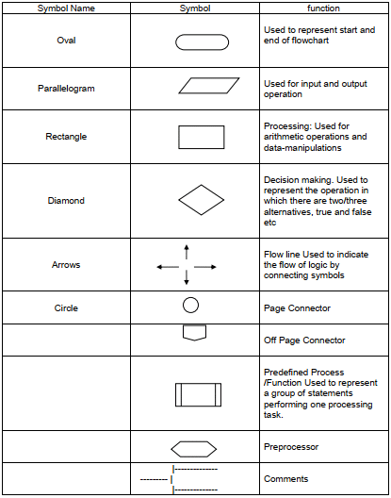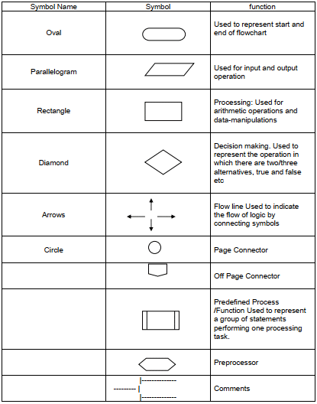Top of Form

Bottom of Form

Assignment 2

Software develop methodology is waterfall methodology

Context models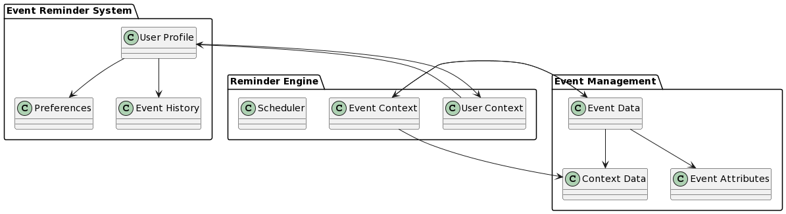

Interaction models 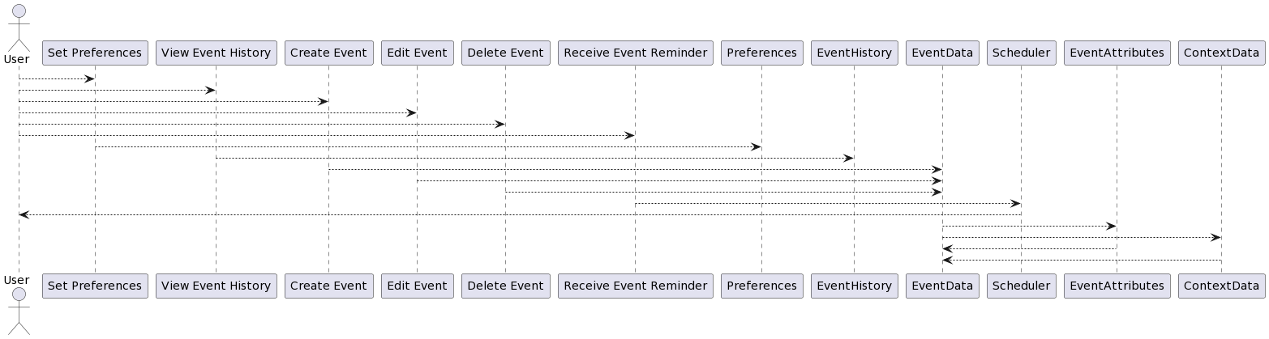

Interaction sequence

These diagrams depict the interactions between the user and the event reminder system for specific tasks or use cases. They show the order of actions, system responses, and user inputs, providing a detailed view of the user-system interaction.

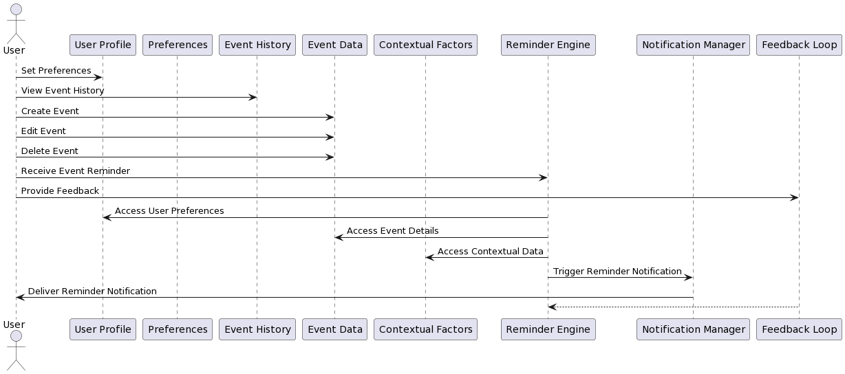Structural models

Entity relationship diagram: This model represents the database structure for event reminders, including the entities (tables), their attributes, and the relationships between them. It helps to visualize the data model and the associations between different data entities.

Class diagram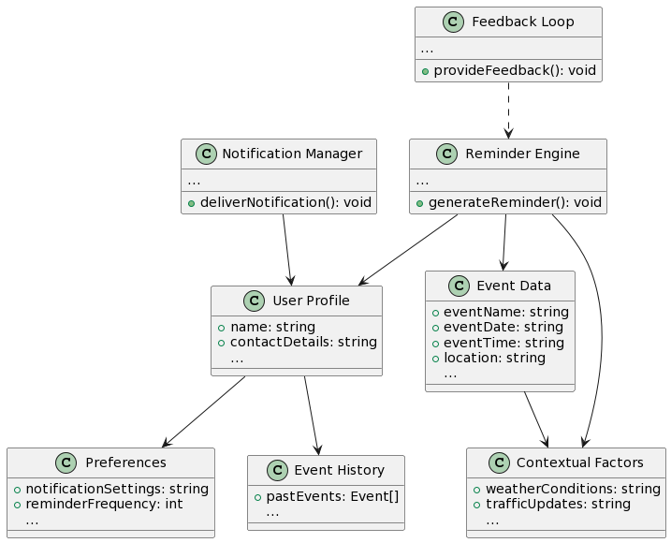

Component models

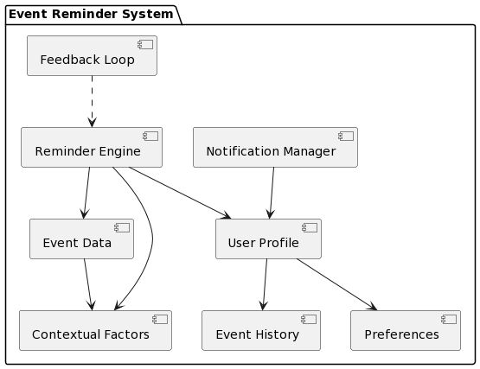

Behavioural models

algorithms or frameworks that use past user behaviour and contextual information to predict and generate effective reminders for upcoming events. These models analyse patterns, preferences, and interactions to personalize reminders and improve their relevance. By considering factors such as user engagement, time sensitivity, and notification channels, these models can optimize the timing, content, and delivery of event reminders to increase user engagement and satisfaction.  
use case diagram

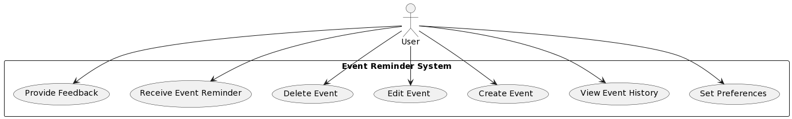

Sequence diagram

